Ryan Balachandran
Bio-Information for CS

Homework #3: PCA Analysis on 20 Amino acids with 8 properties
Due: 2/8/21

Eigen Values: [3.57289, 2.81331, 0.78455 0.42689, 0.27822, 0.00335, 0.04659, 0.07417]

Eigen Vectors: [-0.0577, -0.5848, 0.1059, -0.0962, -0.1686, 0.7388, -0.2153, 0.1156]
[0.2214, -0.4809, 0.1691, -0.1453, 0.6896, -0.1089, 0.3473, -0.2485]
[-0.4435, -0.1040, 0.1425, 0.7331, 0.1614, -0.01043 -0.2299, -0.3943]
[-0.18543, -0.2526, -0.9418, 0.0270, 0.0533, -0.0303, 0.0906, -0.0450]
[0.4929, -0.0326, -0.1279, 0.3544, 0.3428, -0.0665, -0.49456, 0.49741]
[0.5078, 0.0335, -0.1288, -0.1322, -0.1856, 0.0185, -0.4053, -0.7125]
[-0.1004, -0.5658, 0.1409, -0.1119, -0.3669, -0.6599, -0.2350, 0.1093]
[4.53398683e-01, -1.72078630e-01, -3.08983386e-04, 5.25043430e-01,
-4.24677652e-01, 3.02320959e-02, 5.54707886e-01, 1.34890342e-02]

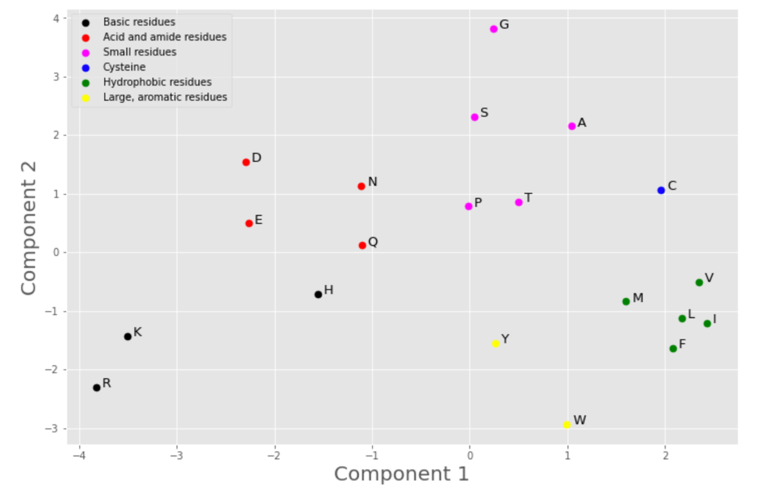

Discussion:

I started this by creating 3 datasets; the original that had all 8 properties, the first letter of the Amino Acid, and the mean and standard deviation. The second dataset I dropped the Amino Acid column, and the third I dropped the mean and standard deviation rows. The article starts by comparing the Volume and pI of amino acids in a graph.

The first step is scaling the values by subtracting each element in each column by the mean, divided by the standard deviation of that column. When using the given mean and standard deviation of the original dataset, the resulting mean and standard deviation should be 0 and 1 respectively. I came out with means and standard deviations not quite equaling 0, but very close. I next made a correlation heatmap to see which properties of Amino Acids are most strongly related together.

At the end, I did not come up with the same principal component values or the same graph. While my graph may not look the same, its because its upside down.

Source Code Appendix

